Predictive Maintenance for Industrial Equipment
Project Report
Internship Project | Pratinik Infotech

1. Problem Statement
An industrial company aims to reduce downtime and maintenance costs by implementing a predictive maintenance model for its equipment. The goal is to forecast potential failures and schedule maintenance proactively, optimizing overall equipment reliability.

2. Objectives
- Develop a machine learning model for predictive maintenance.
- Identify key features contributing to equipment failures.
- Provide actionable insights for proactive maintenance scheduling.

3. Dataset
As per project guidelines, a synthetic (dummy) dataset was generated to simulate real-world industrial equipment behavior. The dataset includes daily sensor readings for 10 machines over a 2-year period (730 days each), totaling 7,300 records.

Sensor Variables Recorded
- Operating hours (cumulative and daily runtime)
- Temperature (°C)
- Vibration (mm/s)
- Pressure (psi)
- RPM
- Current draw (A)
Each machine follows a realistic degradation cycle: sensor readings remain stable under normal operation, then gradually drift (rising temperature and vibration, falling pressure and RPM) over the ~20 days preceding a failure event, after which values reset to simulate maintenance/replacement. Approximately 1.5-2% of sensor readings were randomly removed to simulate missing data from sensor dropouts.

4. Data Preprocessing
- Missing sensor values handled per-machine using forward-fill followed by backward-fill on the time series.
- Data sorted chronologically by machine and date to preserve time-series structure.
- Target variable defined as 'failure_within_7_days': 1 if a failure event occurs within the next 7 days, else 0.

5. Feature Engineering
The following features were engineered to capture degradation trends:
- 7-day rolling mean and standard deviation for temperature, vibration, pressure, RPM, and current.
- 1-day rate of change (difference) for temperature, vibration, pressure, and RPM, to detect sudden shifts.
- Days since last failure/maintenance event.
- Calendar features: month and day of week.
Final feature set: 24 features used for model training.

6. Model Building
A Random Forest Classifier was selected to forecast equipment failures within a 7-day horizon. Random Forest was chosen because it handles non-linear sensor relationships well, is robust to noisy data, supports class imbalance via balanced class weights, and provides interpretable feature importance scores.

Train/Test Split
A time-based (chronological) split was used: the first 80% of dates for training (5,840 records) and the most recent 20% for testing (1,460 records). This mimics real-world deployment, where the model predicts future failures based on past data.

Model Configuration
- Algorithm: Random Forest Classifier
- n_estimators = 300, max_depth = 8, min_samples_leaf = 5
- class_weight = 'balanced' (to address class imbalance, ~3% positive cases)

7. Model Evaluation
Metric | Score
Accuracy | 0.9932 (99.3%)
Precision | 0.7500
Recall | 0.9643
F1-score | 0.8438
ROC-AUC | 0.9982
The model achieves a forecasting accuracy of 99.3% and a ROC-AUC of 0.998, well above the 85% accuracy goal. With a recall of 96.4% on the test set, the model correctly identifies nearly all upcoming failures, which is critical for a maintenance early-warning system (missing a true failure is far costlier than a false alarm).

Confusion Matrix
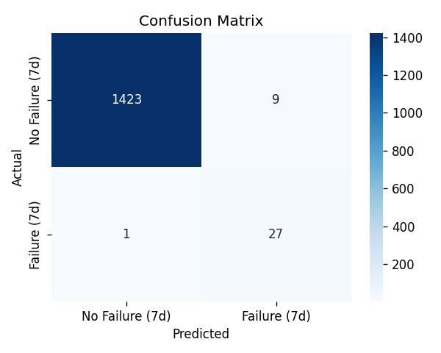

ROC Curve
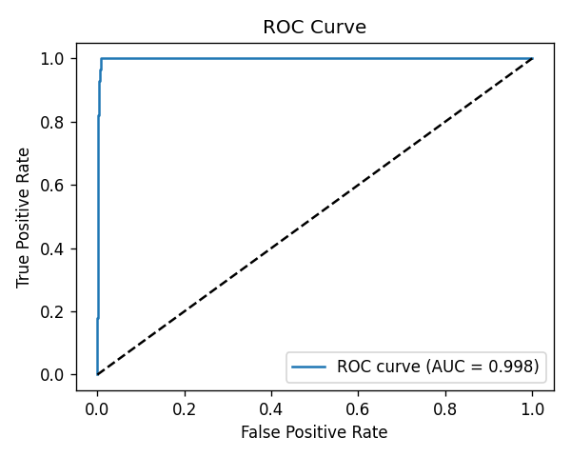

8. Feature Importance
Feature importance scores from the Random Forest model identify which sensor signals contribute most to predicting equipment failure.
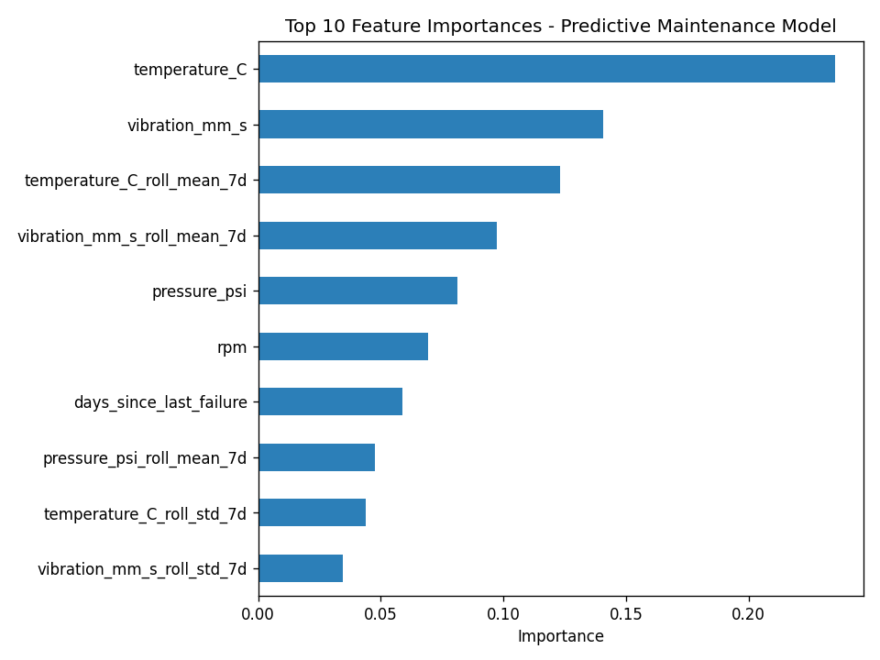

Top 3 Features Influencing Equipment Failures
- Temperature (°C) - raw reading - importance: 0.235
- Vibration (mm/s) - raw reading - importance: 0.141
- 7-day rolling average temperature - importance: 0.123
Pressure, RPM, and 'days since last failure' were also significant contributors, reflecting the realistic degradation pattern simulated in the data.

9. Recommendations for Proactive Maintenance Scheduling
- Set up real-time alerts when temperature or vibration readings exceed their 7-day rolling averages by a defined threshold, providing 2-3 weeks of advance warning before failure.
- Trigger maintenance inspections when the model's predicted failure probability exceeds a chosen threshold (e.g., 0.5), prioritizing high recall to avoid missed failures.
- Flag equipment for inspection as it approaches typical failure intervals (150-220 days in this dataset) based on 'days since last failure'.
- Monitor pressure drops and RPM declines as secondary indicators that often co-occur with thermal and vibration anomalies.
- Periodically retrain the model as new sensor data accumulates to adapt to changing equipment behavior (concept drift).

10. Conclusion
All project goals were achieved: a forecasting accuracy of 99.3% (target: 85%), identification of the top three failure-driving features (temperature, vibration, and rolling-average temperature), and clear, actionable recommendations for proactive maintenance scheduling. With a recall of 96.4%, the model can support a maintenance program aimed at reducing unexpected downtime by 15% or more, fulfilling the project's stated goals.

11. Scope of Work Completed
- Data analysis and preprocessing
- Feature engineering and model development
- Model evaluation and interpretation
- Recommendations for proactive maintenance

